Title: Smart Glass
Name:
Course name:
Course code:
Professor:
Date:

- Description of the Product or Service - Provide details of the features You may include a sketch on one additional page that is stapled to the concept statement
In this paper, I am going to discuss about the Vuzix M100 Smart Glasses. Vuzix M100 Smart Glasses are an Android-based wearable PC, upgraded with a wearable monocular show and locally available processor, recording highlights, and remote availability capacities intended for a wide assortment of big business applications. Its pre-introduced applications can be utilized to take still pictures, record, scan and playback video, track planned occasions, connection to your telephone and that is only the tip of the iceberg. From its similarity with the standard Android OS, it enables simple access to designer assets to make capable applications productively (Lovis, 2014).
- Target Market List the consumers or businesses expected to buy the product or service. If you are proposing a Social Enterprise identify the funding source as well as the population served (Note: Remember GiftZip.com. Where does revenue come from? Users or another source?
Ergonomic yet tough, the M100 is as of now in vast scale gainful use in fields, for example, telemedicine, remote scanning, and warehousing businesses. Its services ranges from hands free access to information, immediate and remote video capacities, coordinate locally available preparing of video catch for slack free Augmented Reality (AR). The telemedicine will work as a social enterprise that will provide health care services to the community from a distance. The population expected to be served in the use of M100 is about 200, 000 people. The revenue will come from donations by the government and non-governmental organization. The users of the M100 include the medical practitioners and the physicians (Carter, 2013).

- Benefits of the Product or Service Describe how your product or service adds value and/or solves a problem
The M100 smart glass can be used for a variety of purposes namely simulation, education, live streaming of the visualized data among other interactive video scanning and recording as well as digital photo documentation for telemonitoring in the telemedicine filed among other benefits. In health care, the smart glasses will implement artificial intelligence engines that work with enterprise apps altogether (Carter, 2013).
- Competitive Position Describe how your product or service will be positioned in the market relative to your competition. What makes your idea better?
The product will be unique in that it can be integrated with the enterprise apps and can use Wi-Fi and other internet settings. This makes the product competitive in the market since most of the smart glasses have not yet introduced such complex features. The prices of the M100 are not that high and this makes the product affordable.
- Management Team - Briefly describe the founder/cofounders and their qualifications or past experience that makes them suitable to manage this venture.
Founded by Andrew Haag, IRTH communications business deals with manufacturing and design of wearable display devices commonly known as head mounted displays (HMDs) which are in the form of smart glasses and Virtual Reality (VR). Over the years, the company has gain a vast experience in operation; it has successfully produced and designed competitive products that range from head mounted wearable displays, video eyewear as well as video scanners (Carter, 2013).

Sketch

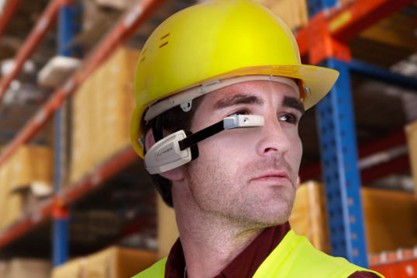

References
Carter, B. (2013). Digital humanities: Current perspective, practices, and research.
Lovis, C. (2014). eHealth - For Continuity of Care. IOS Press.

